VIDEOINTERVISTE MULTIPLIER EVENT MILANO 10.11.2021
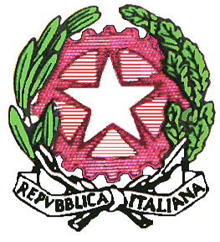
Liceo Scientifico Statale “Elio Vittorini”
20146 Milano Via Mario Donati, 5 - Tel. 02.47.44.48

The European Parliament through his representative in Milan , Mr Molinari , proposes some interesting reflections on the theme of languages and sends its greetings to the participants - of the Multiplier Event related to the COOL PROJECT held at the High School Elio Vittorini ( Liceo Scientifico).

https://youtu.be/a3-zmMGPpNo

Videointervista con il Presidente Vicquery Nicola del Centro Studi e Cultura Walser - Walser Kulturzentrum sulla conservazione e promozione della lingua dei Walser, collegato da Gressoney (Aosta).

https://youtu.be/bfNF6ThrCvc

